Version: | 1.0
Date of version: | 2025-02-28
Created by: | Nicolas Miguel Ching
Confidentiality level: | Confidential [CFN]



Computer Technology (CT) Department

NIS 2024 – NSSECU3: Digital Forensics
File Analysis 101

- Analysis

File types such as bat (. bat), TXT (. txt), and PS1 (. ps1) contain very little metadata mainly file system related properties such as the creation date and size. Word (. docx), Excel (. xlsx), and PowerPoint (. pptx) document can contain a variety of metadata, including author names, modification history, and embedded data (all useful for a collaboration), but they also convey unintended information when shared with an external recipient. Executable files (like EXE and DLL) contain metadata information that is normally found during software development (like software version, company name, etc.) and a digital signature to establish a trust, so that the user can verify whether the file is authentic or not, but at the same metadata can be used as a disguise for malware. Image files like PNG (.png) and JPG (. jpg) enjoy rich metadata including EXIF data that documents your camera settings and time, and even GPS location which can be great for organizing collection, but also present privacy concerns.
The recovery of files depends on the type of file and how much metadata are available. BAT (. bat), TXT (. txt), and PS1 (. ps1) files have very little meta-data, so recovery is mostly reliant on the ability of the filesystem to restore lost directory entries or to reconstruct the file contents from unallocated disk-space. Since these files have no complex structures, they may sometimes be successfully restored, but once overwritten, recovery becomes impossible since that type of file does not embed metadata. Word (.docx), Excel (.xlsx), and PowerPoint (.pptx) files have better recovery chances due to autosave features, temporary backups, and embedded metadata that forensic tools can use to rebuild lost data. EXE (.exe) and DLL (.dll) files are particularly difficult to recover, especially MZ (executable) files, as they often become corrupted, and missing dependencies can render them unusable. Their modified hex values further complicate recovery, making it difficult to determine file integrity. PNG (.png) and JPG (.jpg) images on the other hand, retain EXIF metadata even if their headers are damaged, which helps in restoring lost images.

- Python Code Snippet

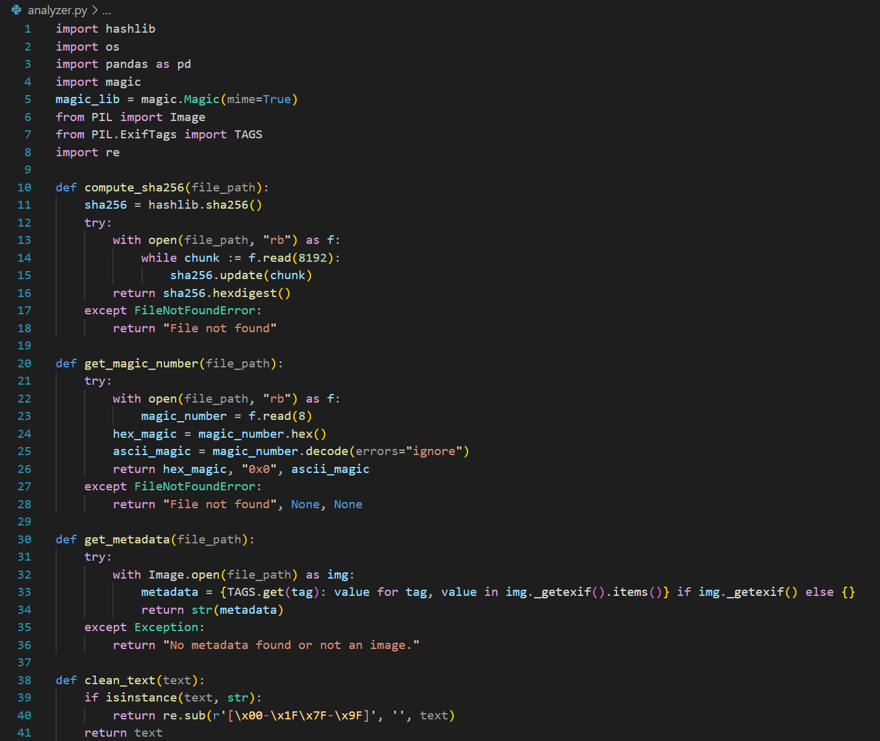
Figure 2.1. Python Code Snippet to Determine File Information

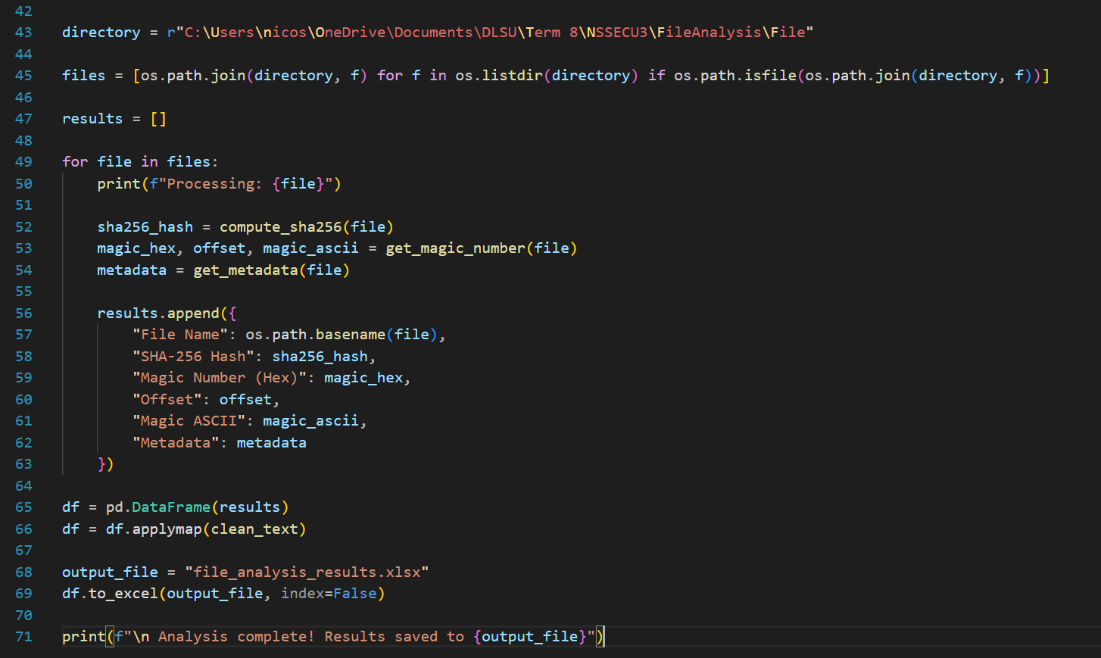
Figure 2.2. Python Code Snippet to Determine File Information

